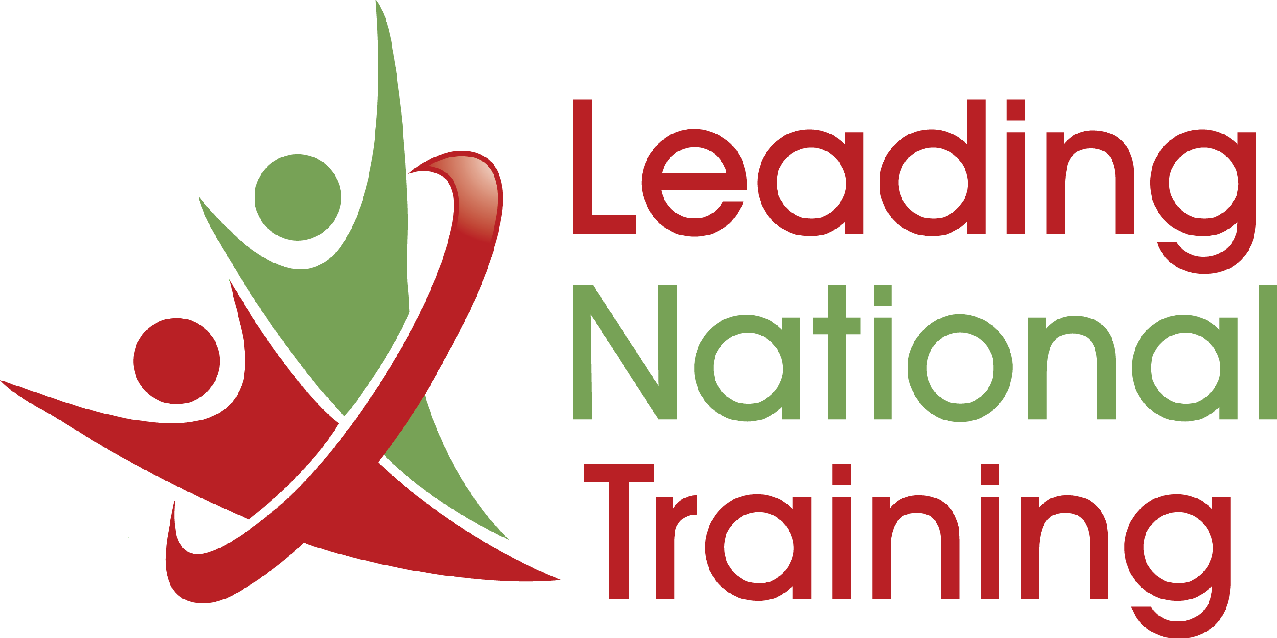

SO, YOU THINK SELLING IS EASY? HERE ARE 74 REASONS
WHY IT IS A SCIENCE. ALL OF THESE TALENTS ARE NEEDED
TO A GREATER OR LESSER DEGREE.

Finding new business

- Prospecting (the starting point)
- Using Social Media and LinkedIn as Sales Tools
- Identifying Potential Profitable Leads
- Qualifying Those Leads
- Identifying Key Decision Makers
- Getting Past Gatekeepers
- Gaining Appointments With Busy People
- Establishing Initial Rapport With Clients
- Managing a Client Engagement
- Managing Other Contacts Within A Client
- Managing Appointments
- Questioning Clients & Completing A Needs Analysis
- Analyzing RFPs, PQQs, RFTs, CRAs + (getting onto PSLs)
- Developing Proposals
- Power Pitching
- Answering Customer Questions/Objections
- Customer Relationship Management
- Using SFA & CRM Tools
- Product/Service Knowledge
- Selling Product Benefits
- Needs Creation
- Analysis of Customers Buy Cycles
- Analysis of Customer-side Politics
- Closing Deals
- Up-Selling

Negotiating

- Negotiating Techniques and Strategy
- Influence Others To Negotiate Whilst Managing Expectations
- Demonstrating Empathy & Understanding of Customer Problems
- Establishing Common Ground
- Persuading When Faced with Negativity Negotiating Techniques
- Dealing with aggressive Techniques
- Dealing with Margin Eroding Techniques
- Diplomacy Techniques
- Solution Seeking
- Getting A Yes, And Acting On It

Sales Operations

- Sales Strategy
- Sales Planning
- Sales Reporting
- Sales Metrics & KPI
- Sales Benchmarking
- Sales Margin Management
- Sales Deal Approvals (Influencing Your Line Managers)
- Manage Customer Relationship Management (CRM) Information
- Sales Communications
- Customer Segmentation
- Liaising With Your Finance & Marketing
- Developing Sales Collaterals

Sales Pipeline Management

- Recognising And Managing Opportunities
- Call Management
- Quote Management
- Order Management
- Order Fulfillment Management
- Account Management
- Customer Retention Management
- Managing Up-sell Activities
- Sales Forecasting

Soft Skills

- Results-focused
- Action-oriented
- Endurance & Persistence
- Dealing With Different Personality types
- Persuasion
- Diplomacy
- Politics
- Public Speaking & Presentations
- Communication Skills
- Active Listening
- Managing First Impressions
- Establishing Rapport
- Building Trust
- Networking
- Time Management
- Meeting Management
- Business Acumen (entrepreneurship)
- Influencing without authority

If you are not reasonably proficient in ALL of them you can potentially fail…

Selling is more art than science. All different types of people are good at it. All different types of people are bad at it.
Selling is a complex combination of emotional intelligence and business acumen. Contrary to popular belief, you're not born with it.
Selling is a skill that can be learned. More accurately, selling skills can be continuously improved with experience and knowledge.

For further information of our sales training programmes, please contact: info@leadingnationaltraining.co.uk

